Show edit page for user/post conditionally to only admin or logged in user who is also the creator of the post or wants to update his/her profile.

Currently a logged in user can go to other user's profile. Then manually update the url with '.../edit/...' to land on other user's profile update page.

And it's same for post edit as well.

There is validation in the backend, So they won't be able to update other user's profile or post. However it's nice to hide the edit form and show it to only admin or the same user who created it.

**/user/EditProfile.js**

Put the following code inside render(), just before the closing </div>

{isAuthenticated().user.role === "admin" ||

(isAuthenticated().user._id === id &&

this.signupForm(name, email, password, about))}

Let's do the same for post edit.

**/post/EditPost.js**

Make the following change in init() and render()

init = postId => {

singlePost(postId).then(data => {

if (data.error) {

this.setState({ redirectToProfile: true });

} else {

this.setState({

// id is not post.postedBy._id

id: data.postedBy._id,

title: data.title,

body: data.body,

error: ""

});

}

});

};

{isAuthenticated().user.role === "admin" ||

(isAuthenticated().user._id === id &&

this.editPostForm(title, body))}

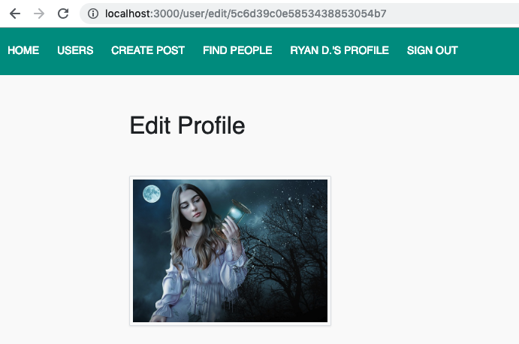

That's it! Now if any logged in user tried to go to other user's edit page by manually updating route with '.../edit/...' they will not see the edit form. And it works similarly on editPost as well.